Partial / residual correlation: EURUSD and USDJPY
Method 07 / daily log returns / leave-currency-out USD factor / Alpari D1 full available history

Study setup
Logical pair: EURUSD , USDJPY
Broker symbols: EURUSD_i , USDJPY_i
Snapshot: 2026-11-03_majors_alpari_D1
Timeframe: D1
Matched return window: 1999-01-05 to 2026-11-02 (UTC bar dates)
Matched return count n: 7148
Dropped unfinished last bar dated 2026-11-03 UTC after a tick-volume check against the prior complete day.
USD-strength sign rule: minus log return when USD is the quote (EURUSD, GBPUSD, AUDUSD, NZDUSD); plus log return when USD is the base (USDJPY, USDCHF, USDCAD). EURGBP is never a constituent.
Control z constituents (5): GBPUSD, AUDUSD, NZDUSD, USDCHF, USDCAD
z_t = equal-weight mean of those USD-strength returns on the same day
Complete matched rows (Excel): EURUSD-USDJPY_Partial_D1.xlsx
Complete matched rows (HTML table): EURUSD-USDJPY_Partial_D1_data.html

Method carried forward
Partial / residual correlation regresses each matched daily log return of close, ln(close_t / close_t-1), on the same leave-currency-out USD strength factor z, then takes Pearson correlation of the two residual series. Quotes are not inverted. z is the equal-weight mean of USD-strength returns from other majors that do not share a non-USD currency with either leg; EURGBP is never a constituent. USD-strength is minus the log return when USD is the quote (EURUSD, GBPUSD, AUDUSD, NZDUSD) and plus the log return when USD is the base (USDJPY, USDCHF, USDCAD). OLS uses an intercept on each leg. rho_partial is symmetric under swap of the two symbols. It describes leftover linear co-movement after removing linear z; it is not a cause, not a lead, and not a trading signal. Daily rows are not independent and residuals are estimated, so the two-sided p-value and Fisher interval are secondary. Same-sample raw Pearson r is a side check only.

Regression on z
leg | intercept_a_or_c | slope_b_or_d | R2
EURUSD | -2.121e-05 | -0.84630138 | 0.56393172
USDJPY | 5.852e-05 | 0.2601265 | 0.04650976

Results
rho_partial: -0.214654
Two-sided p-value: 2.7816e-75
Approximate 95% Fisher interval: [-0.236659, -0.192428]
Same-sample raw Pearson r: -0.300364
rho_partial minus r: 0.085710

Conclusion
Over 7148 matched daily rows for EURUSD and USDJPY after removing a leave-currency-out USD factor built from 5 constituents, rho_partial is -0.2147 (negative, weak residual linear link in this sample). Approximate 95% Fisher interval: [-0.2367, -0.1924]. Same-sample raw Pearson r is -0.3004 (partial minus r = 0.0857). Leg R-squared on z: EURUSD=0.5639, USDJPY=0.0465. Two-sided p under the usual independent-pairs model is 2.782e-75; residuals are estimated and daily FX rows are linked, so treat p as secondary. This does not establish cause, lead-lag, or a lasting trading rule.

Charts
Daily closes
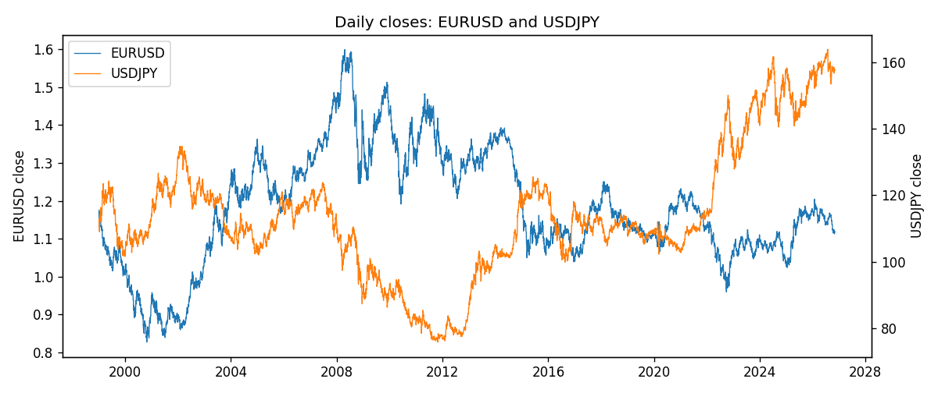
Log returns and control z
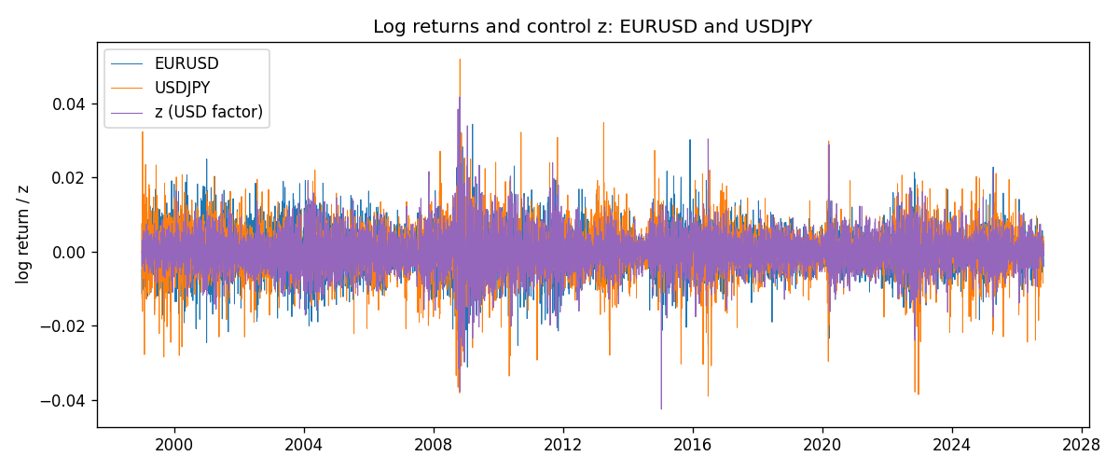
Residual scatter e_x vs e_y
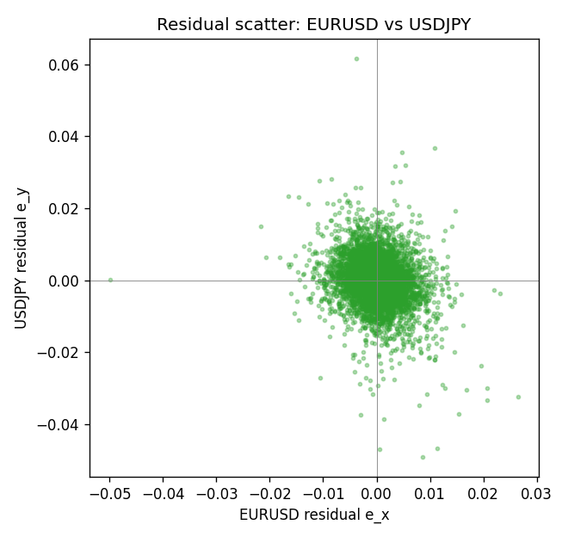

Data report
Every matched row that entered the partial correlation is stored in the sibling Excel workbook named EURUSD-USDJPY_Partial_D1.xlsx. That file is the complete data archive for redrawing charts. Embedding all rows as a Word table is impractical at this length; the Word file holds the column list, column summaries, and the first and last 15 matched rows.
Columns: time, EURUSD_open, USDJPY_open, EURUSD_high, USDJPY_high, EURUSD_low, USDJPY_low, EURUSD_close, USDJPY_close, EURUSD_tick_volume, USDJPY_tick_volume, EURUSD_spread, USDJPY_spread, EURUSD_real_volume, USDJPY_real_volume, EURUSD_log_return, USDJPY_log_return, usd_strength_GBPUSD, usd_strength_AUDUSD, usd_strength_NZDUSD, usd_strength_USDCHF, usd_strength_USDCAD, z, EURUSD_fitted, USDJPY_fitted, EURUSD_resid, USDJPY_resid
Column summaries (matched calculation rows)
column | count | mean | std | min | 25% | 50% | 75% | max
EURUSD_open | 7148 | 1.1816879 | 0.15074041 | 0.8272 | 1.0863875 | 1.16609 | 1.2942 | 1.5995
USDJPY_open | 7148 | 113.80278 | 19.266728 | 75.693 | 104.3275 | 110.969 | 120.725 | 163.824
EURUSD_high | 7148 | 1.1868219 | 0.15134312 | 0.8326 | 1.0904675 | 1.17121 | 1.29957 | 1.6038
USDJPY_high | 7148 | 114.30008 | 19.328348 | 76.001 | 104.8345 | 111.426 | 121.27175 | 163.978
EURUSD_low | 7148 | 1.1766784 | 0.15005373 | 0.8227 | 1.0822025 | 1.162475 | 1.2886225 | 1.5865
USDJPY_low | 7148 | 113.28032 | 19.194266 | 75.402 | 103.8475 | 110.515 | 120.19 | 163.628
EURUSD_close | 7148 | 1.1817317 | 0.15070664 | 0.8267 | 1.0862225 | 1.16602 | 1.2942 | 1.5997
USDJPY_close | 7148 | 113.81631 | 19.281858 | 75.811 | 104.3175 | 110.995 | 120.7025 | 163.851
EURUSD_tick_volume | 7148 | 103711.54 | 173856.26 | 469 | 9484.75 | 52998 | 99801.75 | 1471626
USDJPY_tick_volume | 7148 | 106851.22 | 179762.89 | 197 | 10008.25 | 53482.5 | 93111.75 | 1803508
EURUSD_spread | 7148 | 19.246223 | 16.509774 | 0 | 8 | 12 | 20 | 50
USDJPY_spread | 7148 | 20.16704 | 17.582453 | 0 | 6 | 11 | 30 | 50
EURUSD_real_volume | 7148 | 4.0536992e+10 | 1.6733469e+11 | 0 | 0 | 0 | 0 | 3.6149665e+12
USDJPY_real_volume | 7148 | 3.4953653e+10 | 1.6133327e+11 | 0 | 0 | 0 | 0 | 3.8834203e+12
EURUSD_log_return | 7148 | -2.16e-06 | 0.0058013 | -0.03123819 | -0.00324218 | 0 | 0.00325609 | 0.03433183
USDJPY_log_return | 7148 | 5.267e-05 | 0.00620906 | -0.03908203 | -0.00319392 | 0.00012736 | 0.00340928 | 0.05184024
usd_strength_GBPUSD | 7148 | 1.992e-05 | 0.00564699 | -0.03112653 | -0.00318167 | -3.426e-05 | 0.0031217 | 0.08388241
usd_strength_AUDUSD | 7148 | -3.157e-05 | 0.00755018 | -0.0806166 | -0.00415111 | -0.00029168 | 0.00385014 | 0.08602525
usd_strength_NZDUSD | 7148 | -1.914e-05 | 0.00764519 | -0.05966839 | -0.004586 | -0.00023666 | 0.00424201 | 0.07027433
usd_strength_USDCHF | 7148 | -6.945e-05 | 0.0065937 | -0.19545699 | -0.00334697 | 8.15e-05 | 0.00331954 | 0.09051364
usd_strength_USDCAD | 7148 | -1.226e-05 | 0.00514518 | -0.03859748 | -0.00283513 | 4.873e-05 | 0.00272781 | 0.03436319
z | 7148 | -2.25e-05 | 0.0051477 | -0.04256935 | -0.00285722 | -4.632e-05 | 0.00285656 | 0.04166723
EURUSD_fitted | 7148 | -2.16e-06 | 0.00435651 | -0.03528425 | -0.00243872 | 1.799e-05 | 0.00239687 | 0.03600529
USDJPY_fitted | 7148 | 5.267e-05 | 0.00133905 | -0.0110149 | -0.00068472 | 4.647e-05 | 0.00080159 | 0.01089727
EURUSD_resid | 7148 | 0 | 0.00383091 | -0.04994673 | -0.0020941 | -1.524e-05 | 0.00204366 | 0.02657056
USDJPY_resid | 7148 | 0 | 0.00606295 | -0.04907342 | -0.0029668 | 0.00011798 | 0.00309095 | 0.06158005
First 15 matched rows (selected columns)
time | EURUSD_close | USDJPY_close | EURUSD_log_return | USDJPY_log_return | z | EURUSD_fitted | USDJPY_fitted | EURUSD_resid | USDJPY_resid
1999-01-05 | 1.1758 | 111.92 | -0.0048360507 | -0.00017868311 | -0.00012572145 | 8.5191336e-05 | 2.5815627e-05 | -0.004921242 | -0.00020449873
1999-01-06 | 1.1623 | 112.77 | -0.011547966 | 0.0075660159 | -4.8290354e-07 | -2.079822e-05 | 5.8393493e-05 | -0.011527168 | 0.0075076224
1999-01-07 | 1.1712 | 111.33 | 0.0076280636 | -0.012851583 | -0.0041821617 | 0.0035181623 | -0.001029372 | 0.0041099012 | -0.011822211
1999-01-08 | 1.1585 | 110.8 | -0.010902799 | -0.0047719894 | 0.0030249948 | -0.0025812641 | 0.00084540042 | -0.0083215352 | -0.0056173898
1999-01-11 | 1.1503 | 109.02 | -0.007103287 | -0.016195423 | -0.0020088262 | 0.0016788655 | -0.00046402984 | -0.0087821525 | -0.015731393
1999-01-12 | 1.1555 | 112.6 | 0.0045103728 | 0.032310364 | 0.00094056184 | -0.00081720568 | 0.00030318417 | 0.0053275785 | 0.03200718
1999-01-13 | 1.1681 | 113.52 | 0.010845346 | 0.0081373171 | -0.00099725703 | 0.0008227731 | -0.00020089388 | 0.010022573 | 0.008338211
1999-01-14 | 1.1681 | 113.52 | 0 | 0 | 0.0010913836 | -0.00094484631 | 0.0003424169 | 0.00094484631 | -0.0003424169
1999-01-15 | 1.1563 | 114.15 | -0.010153245 | 0.0055343401 | 0.0015254749 | -0.0013122184 | 0.00045533555 | -0.0088410266 | 0.0050790046
1999-01-18 | 1.1605 | 114.16 | 0.0036256946 | 8.7600193e-05 | -0.0004999169 | 0.00040187346 | -7.1522526e-05 | 0.0032238211 | 0.00015912272
1999-01-19 | 1.1603 | 113.52 | -0.00017235436 | -0.0056219403 | -0.0016561646 | 0.0013804075 | -0.0003722932 | -0.0015527619 | -0.0052496471
1999-01-20 | 1.1566 | 112.91 | -0.0031939256 | -0.0053879917 | 0.00016730669 | -0.00016279878 | 0.00010204001 | -0.0030311268 | -0.0054900317
1999-01-21 | 1.1601 | 113.87 | 0.0030215416 | 0.0084664056 | -0.0032202575 | 0.0027041014 | -0.00077915521 | 0.00031744012 | 0.0092455608
1999-01-22 | 1.1587 | 114.56 | -0.0012075213 | 0.0060412564 | 0.0048374957 | -0.0041151862 | 0.00131688 | 0.0029076649 | 0.0047243764
1999-01-25 | 1.1552 | 113.72 | -0.0030251979 | -0.0073594164 | 0.0019226832 | -0.0016483764 | 0.00055865997 | -0.0013768215 | -0.0079180764
Last 15 matched rows (selected columns)
time | EURUSD_close | USDJPY_close | EURUSD_log_return | USDJPY_log_return | z | EURUSD_fitted | USDJPY_fitted | EURUSD_resid | USDJPY_resid
2026-10-13 | 1.11965 | 158.305 | 0.0037402957 | -0.0018932826 | -0.0038023894 | 0.0031967605 | -0.00093058315 | 0.00054353525 | -0.00096269942
2026-10-14 | 1.11545 | 158.317 | -0.0037582255 | 7.5800166e-05 | 0.002924749 | -0.002496426 | 0.00081932385 | -0.0012617995 | -0.00074352368
2026-10-15 | 1.12172 | 158.024 | 0.0056053107 | -0.0018524319 | -0.0034424206 | 0.0028921184 | -0.00083694572 | 0.0027131923 | -0.0010154862
2026-10-16 | 1.12371 | 157.964 | 0.0017724895 | -0.00037976126 | -0.0039910471 | 0.0033564217 | -0.00097965801 | -0.0015839323 | 0.00059989675
2026-10-19 | 1.12086 | 158.517 | -0.0025394633 | 0.0034946841 | -0.00069520713 | 0.00056714785 | -0.00012232269 | -0.0031066111 | 0.0036170068
2026-10-20 | 1.12354 | 158.16 | 0.0023881672 | -0.0022546642 | -0.0038218088 | 0.0032131952 | -0.00093563466 | -0.00082502795 | -0.0013190296
2026-10-21 | 1.12318 | 158.108 | -0.00032046717 | -0.00032883504 | -0.0018387593 | 0.0015349376 | -0.00041979091 | -0.0018554048 | 9.0955871e-05
2026-10-22 | 1.12139 | 156.755 | -0.0015949606 | -0.0085942669 | -0.00061750945 | 0.00050139219 | -0.00010211146 | -0.0020963528 | -0.0084921554
2026-10-23 | 1.11989 | 156.81 | -0.001338521 | 0.00035080446 | 0.00046524251 | -0.00041494228 | 0.00017954102 | -0.00092357877 | 0.00017126345
2026-10-26 | 1.11735 | 157.458 | -0.0022706559 | 0.0041238746 | 0.0020869289 | -0.0017873777 | 0.00060138464 | -0.00048327816 | 0.00352249
2026-10-27 | 1.11272 | 157.894 | -0.004152342 | 0.0027651658 | 0.0012219697 | -0.0010553616 | 0.00037638582 | -0.0030969804 | 0.0023887799
2026-10-28 | 1.1152 | 157.743 | 0.0022262927 | -0.00095679538 | -0.00015849639 | 0.00011292881 | 1.7289997e-05 | 0.0021133639 | -0.00097408538
2026-10-29 | 1.11772 | 157.683 | 0.0022571351 | -0.00038043789 | -0.0010201856 | 0.00084217756 | -0.0002068582 | 0.0014149576 | -0.00017357969
2026-10-30 | 1.11644 | 157.516 | -0.0011458446 | -0.0010596481 | -0.00057292055 | 0.00046365655 | -9.0512711e-05 | -0.0016095012 | -0.00096913542
2026-11-02 | 1.11881 | 157.933 | 0.002120569 | 0.0026438521 | -2.2623022e-05 | -2.0610072e-06 | 5.2634261e-05 | 0.00212263 | 0.0025912178

